We Make Events – North American Call to Action
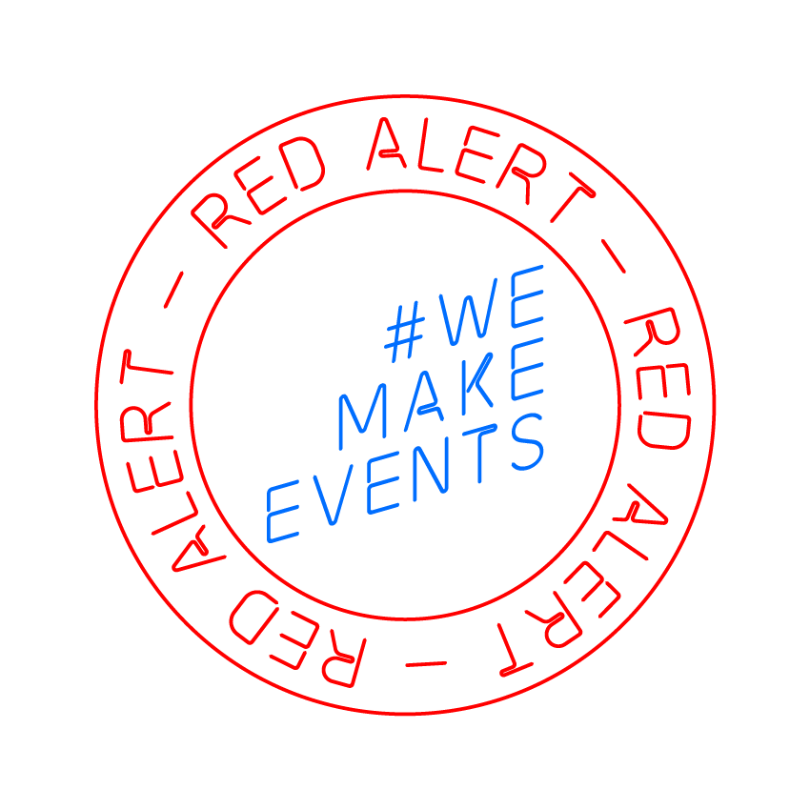
#WeMakeEvents

November 4, 2020

To Whom it May Concern,

As you are aware, the Live Event and Entertainment Industry came to a grinding halt in March of this year due to the COVID-19 pandemic. We saw businesses closing and millions out of work or underemployed. All through no fault of their own. This could include you, a family member, or someone you know or are close to. While some pieces of the economy are picking back up, those in Live Events cannot go fully back to work, and likely will be one of the last to return to full operations (well into 2021); let alone restore former prosperity (possibly not until 2022 or beyond).

In September of this year, thanks to assistance from people like you, we were able to raise awareness to the Live Entertainment Industry situation through the wildly successful RedAlertRESTART Event. 3,000 buildings, companies and homes lit red across the United States to literally shine a light on how many have been affected. And we have YOU to thank!

9 Months after the pandemic shutdown and 2 months after the RedAlertRESTART event, we are closer to government assistance, but not quite there yet. As Michael Strickland of Bandit Lites states, “We Have a Choice;
#1 Do Something
#2 Do Nothing
# If we do nothing, we get nothing.”

We are asking you to please stand hand in hand with us once again by spreading a video message that we will produce and provide to you. The RESTART Act is a bill that is currently moving through congress but has stalled. Please know that the RESTART Act does not just benefit Entertainment venues and production companies. It is written to benefit ALL small business. To help our displaced workers we are also supporting the efforts of ExtendPUA.org by asking for an extension and expansion of PUA and FPUC.

This campaign is easy. You can help by spreading our video content on Tuesday November 10th
Between 9:00am – 9:00pm in each of our local time zones. The video will be provided to our Social Media Platform. Please post to any of your own personal Social Media, Facebook, Twitter, Instagram

If you or your company has an “email blast” list, please send to your list

If you have an electronic marquee please run our video
- Please send to your friends and co-workers and ask that they do the same
- Send to your Congressional Representatives
- ANY OTHER ideas you have to get our video seen… please get it out there!

Those in the industry are doing everything they can to get to the other side of this. Can we show them they are not alone? Our goal is 1,000 placements of our video message. Your participation means the world in terms of visibility and comradery. You may never truly understand the impact it brings.

Thank you in advance for standing with us again.
The entertainment community of North America #WeMakeEvents #RedAlertRESTART #ExtendPUA

