I wish to thank you for your leadership through the pandemic and for passing Save Our Stages. This bill helped all of the venues, mangers, agents, and promoters survive this difficult time.

The MUSIC Act (Music Under Sever Income Crisis) was introduced in the Senate September 14th, and it will allow those important people left behind by SVOG to also receive assistance.

There are thousands of entities and people that are on the edge of disaster, and they have no other source of relief. This includes all the women and men that work in the theaters, delivering the sound, lights, trucks, costumes, tickets, catering, instruments, and other such functions. They do not work directly for the venues, but they too need assistance.

The MUSIC Act should require no additional funding as there is now over $4 billion dollars remaining in SVOG after supplemental grants. The entire live entertainment industry urges you to pass this as quickly as possible by Unanimous Consent. Passage will complete the original mission to save the live entertainment industry. As of Monday October 18th $11.3 billion, dollars had been awarded, and all but 262 applications were resolved. That leaves $4.9 billion from the original fund of $16.2 billion. SVOG is now closed.

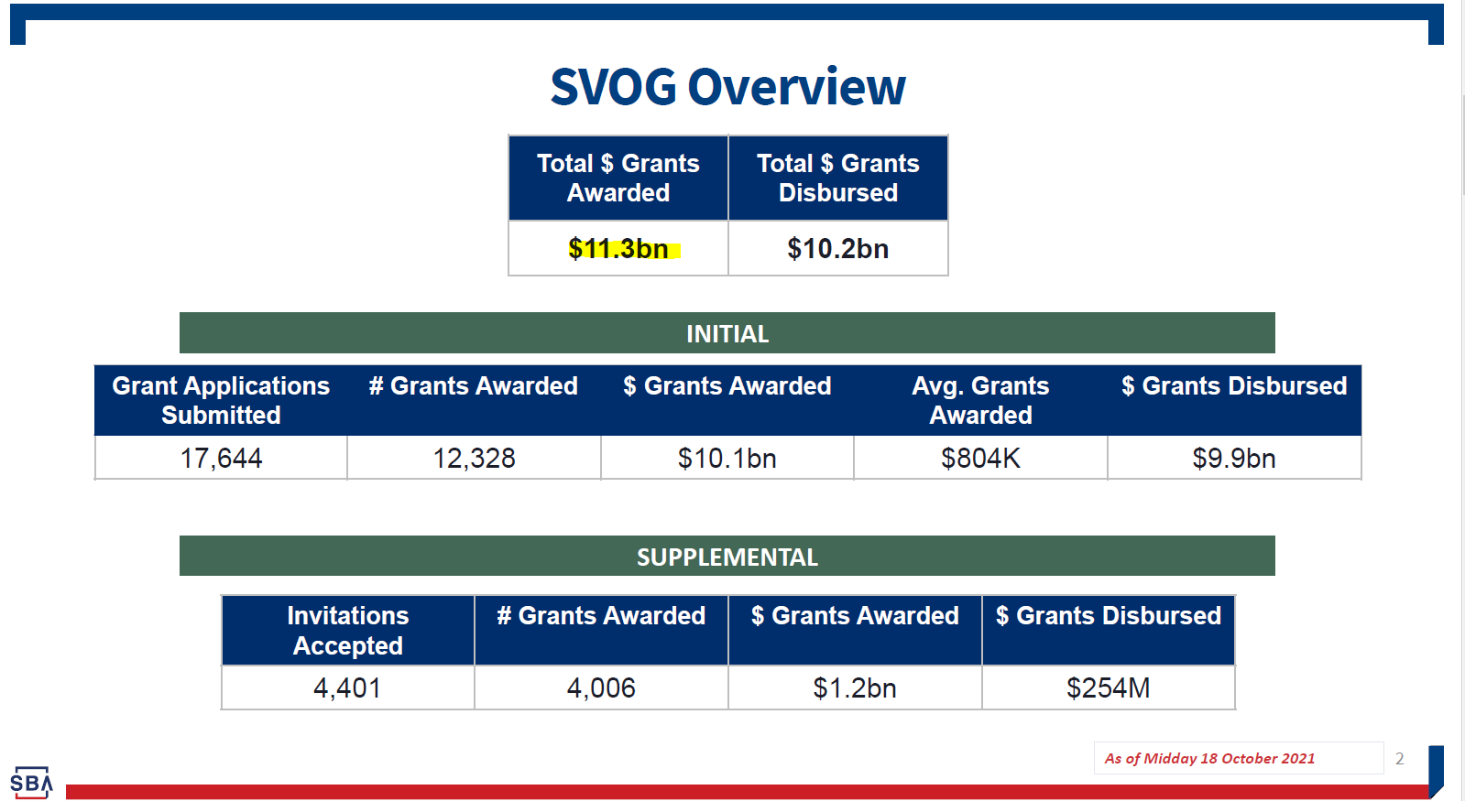

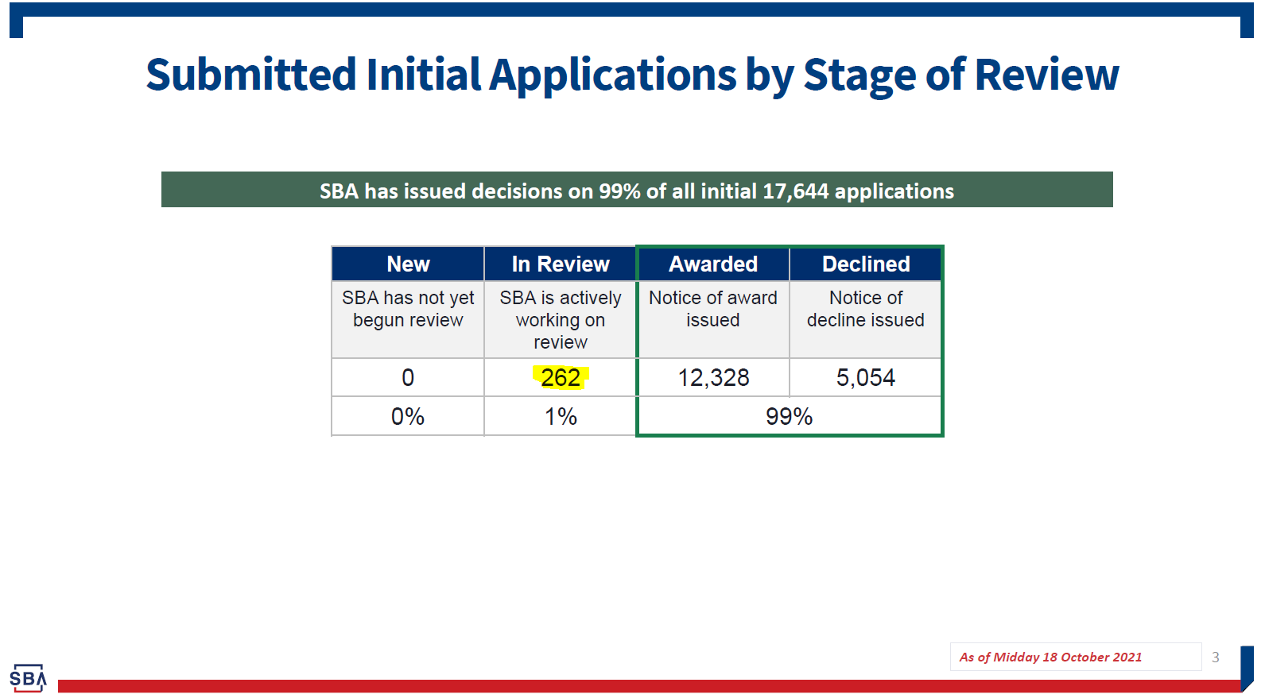

The Delta Variant is growing, and the live entertainment industry is again staggering. The MUSIC Act is the only thing that will save those not helped previously by SVOG. Thank you in advance for your consideration and the people in the industry are grateful for your assistance.

Thank you,

